EENG 385 - Electronic Devices and Circuits

Lab 9 – Active Filters

Lab Handout

**Filter Behavior Simulation**

**Low-pass Filter**

1. With no DC bias applied to the input AC source, is the output of the low-pass filter an accurate reproduction of the input?

**The output is not a faithful reproduction of the input, because the output is clipped.**

1. Include a copy of your Excel data for the Bode plot. That is cells B3 throughF14. A screen shot using the snipping tool would be satisfactory.

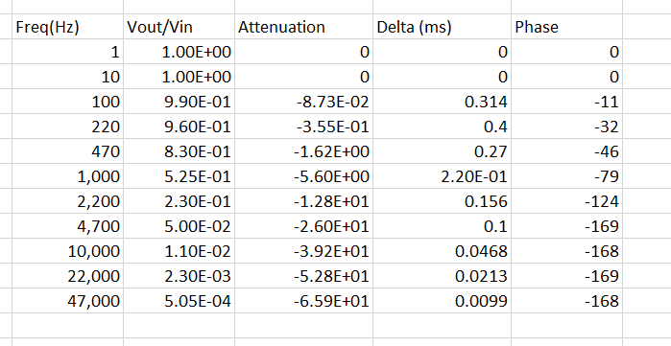

1. Include a copy of your Bode plot from Excel as the answer to this question. A screen shot using the snipping tool would be satisfactory.

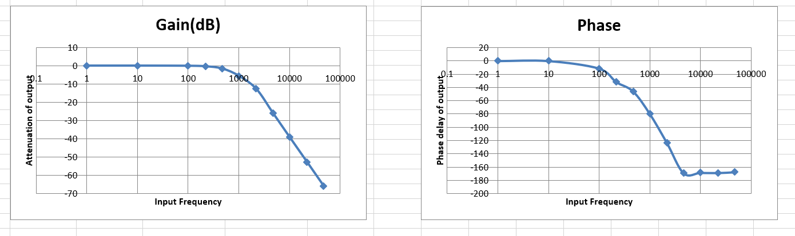

1. Given the component values in Figure 3, what is corner frequency of the low-pass filter on the audio board?

**The corner frequency of the low-pass filter in Figure 3 is 1.06kHz.**

1. Given the data that you collected from the Multisim Live simulation, what is the corner frequency of the low-pass filter?

**The corner frequency of the simulated low-pass filter is a little above 1.0kHz.**

1. Include your Bode plot for the output as your answer to this question.

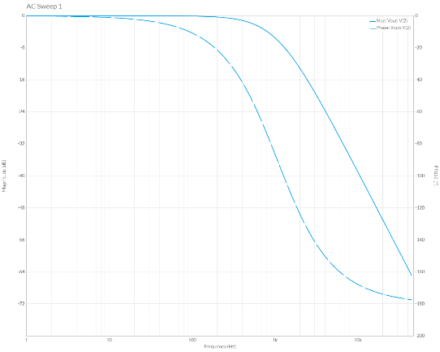

**High-pass Filter**

1. With no DC bias applied to the input AC source, is the output of the low-pass filter an accurate reproduction of the input? You should ignore any DC bias added to the output.

**The output is a faithful reproduction of the input.**

1. Given the equation above and the component values in Figure 5, what is corner frequency of the low-pass filter on the audio board?

**The corner frequency of the high-pass filter is 1.06kHz.**

1. Include the Grapher output of your Bode plot as the answer to this question. Use the export Grapher image feature.

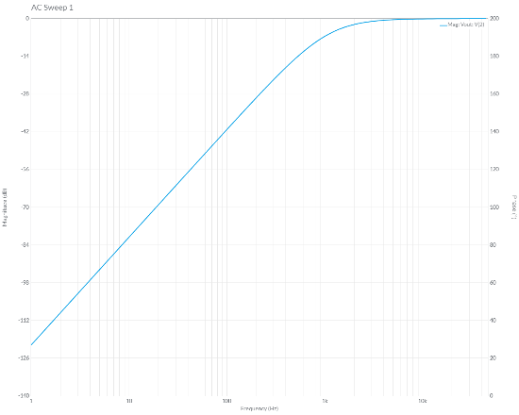

1. Compare the corner frequency you calculated using the equation against the -6dB frequency from the Bode plot. Are they close?

**The calculated -6dB frequency is 1.06kHz, the -6dB frequency from the Bode plot is almost identical.**

**Band-pass Filter:**

1. With no DC bias applied to the input AC source, is the output of the low-pass filter an accurate reproduction of the input? You should ignore any DC bias added to the output.

**The output is a faithful reproduction of the input.**

1. Include the Grapher output of your Bode plot as the answer to this question. Use the export Grapher image feature.

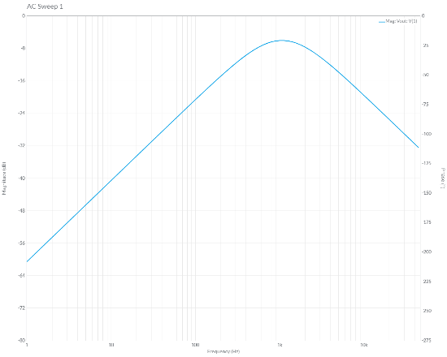

1. Compare the center frequency you calculated using the equation against the -6dB frequency from the Bode plot. Are they close?

**The calculated -6dB frequency is 1.06kHz, the -6dB frequency from the Bode plot is almost identical.**

**Level Shifter**

1. Look at the POT schematic symbol after changing its PosPercent, did the center tap move closer to the VCC or GND terminal?

**The center tap moved 90% of the way to the GND terminal.**

1. What would you expect the DC voltage out of the potentiometer to equal?

**The potentiometer will output 10% of 5V or 0.5V.**

1. With the 0.5V DC bias applied to the input AC source, is the output of the level-shifter an accurate reproduction of the input? You should ignore any DC bias added to the output.

**The output is not a faithful reproduction of the input because the output is clipped at ground.**

1. What is the smallest DC bias voltage you would need to the AC input in order to avoid clipping? Test your answer.

**We would have to set the potentiometer to 80% to generate a 1V DC bias. This would cause the output waveform to just touch 0V at its lowest point.**

1. Include the Grapher output of your Bode plot as the answer to this question. Use the export Grapher image feature.

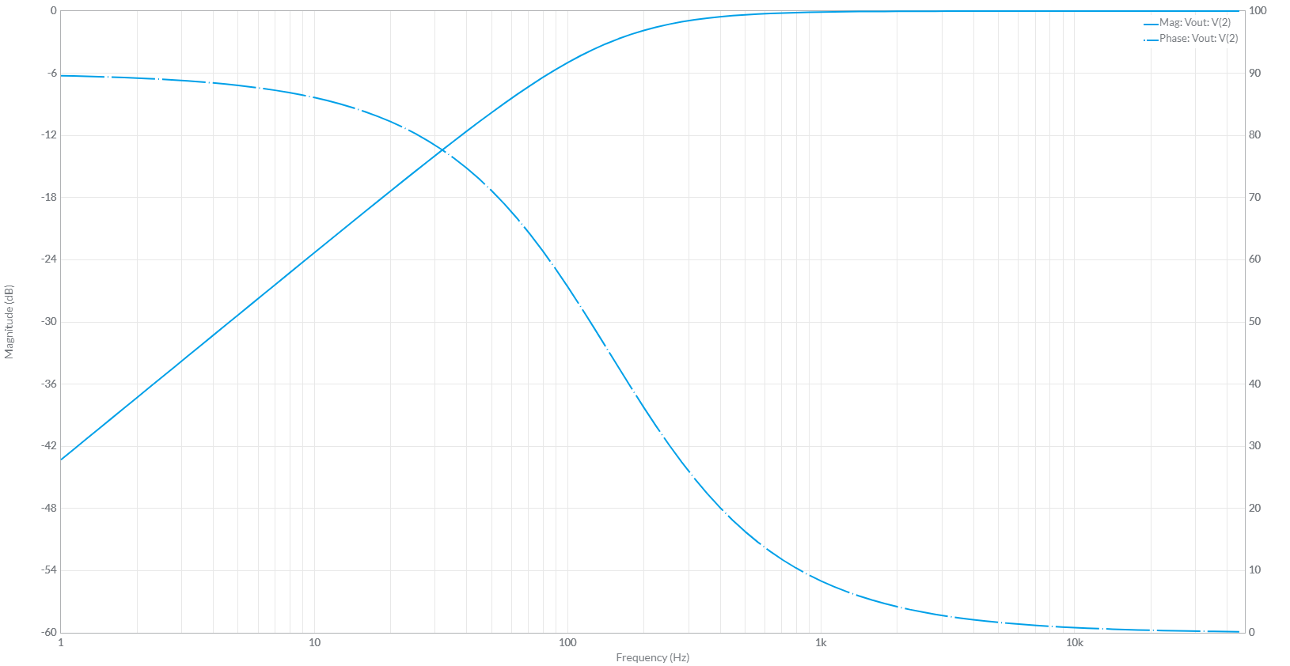

1. Complete the following items.

* Set the potentiometer to 80% in MultiSim Live,
* Compute the effective resistance of the potentiometer that is set to 80% to an AC signal,

**20kΩ || 80kΩ = 16kΩ**

* Compute the corner frequency using the equation above,

**The corner frequency is 1/(2*pi*16kΩ*68nF) = 146Hz**

* Run an AC Sweep to generate the Bode plot and verify the computed corner frequency

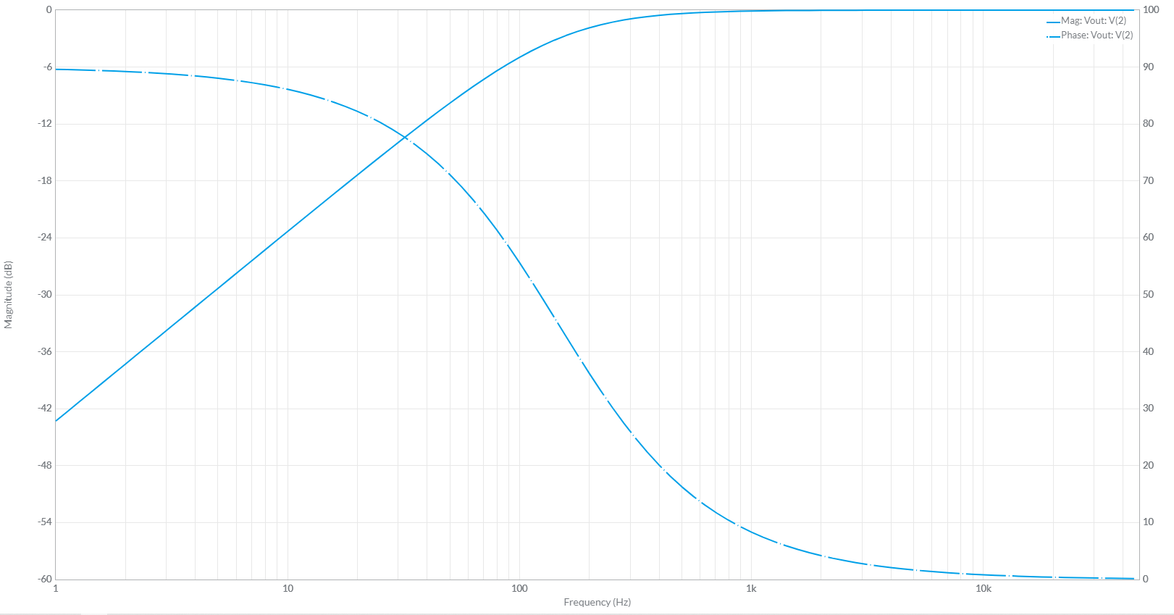

# Audio Board Filter Interface:

Now create the Bode plots for the high-pass, band-pass and level shifter using the respective tabs in the Excel spreadsheet. Make sure that the level shifter is set to 2.5V bias.

**Low Pass Filter Experimental Data**

**High Pass Filter Experimental Data**

**Band Pass Filter Experimental Data**